Calculation Policy adapted from the White Rose Maths Hub, with additions and further materials. This is a working document and will be revised and amended as necessary.

|  |  |  |  |
| --- | --- | --- | --- |
|  | Concrete  Reception | Pictorial | Abstract |
| Count reliably with numbers from 1-20. | Using objects to count, lining objects up, touch counting. | Count pictures, objects than cannot be moved. | Encouraging children in their play |
| Place numbers 1-20 in order. | Order numbers, objects with numbers on, outdoor number ordering. | Placing numbers in order on a numberline. | Placing missing numbers on a numberline.  Talking about which numbers come before or after a given number.  Encouraging children in their play |
| Say which number is 1 more or 1 less than a given number. | Using objects to add one more or take one away to find one more or one less. | Use + and – signs to begin to link together 1 more and 1 less (more +, less -). | Missing numbers in a sequence forwards and backwards.  5 _ 7  6 _ 8  9 _ 7  Encouraging children in their play |
| Using quantities and objects, add and subtract 2 single digit numbers. | Using objects to add 2 single digit numbers e.g. cars, bears, pebbles etc.  Using objects to subtract a single digit number from a single digit number. | Pictures of objects for children to add.  Pictures of objects for children to subtract by crossing out. | Model and show children 3 + 1 = 4 number symbols and number sentences and what each symbol represents.  Encouraging children in their play. |
| Count on and back to find the answer. | Using objects and fingers to place a number in heads and count on or back.  Pick a number, place it in a box and then add or subtract to find the answer using fingers.  Use objects to support. | Children start with a number and count on or back to find the answer. | Encouraging children in their play |
| Vocabulary to be used | Games and songs to be used to begin using vocabulary involved in addition and subtraction.  Addition – add, more, sum, total, altogether, count on, greater than, bigger  Subtraction – take away, subtract, left, less, fewer, counting back, smaller | | |

|  |  |  |  |
| --- | --- | --- | --- |
| Objective & Strategy | Concrete  Addition - Year 1 | Pictorial | Abstract |
| Combining two parts to make a whole: part – whole model | A variety of resources can be used (eggs, shells, pebbles, teddy bears, cars etc) | Children to represent the cubes using dots or crosses. They could put each part on a part whole model too. | 4 + 3 = 7 Four is a part, 3 is a part and the whole is 7.    10 = 6 + 4. 10 is the whole, 4 and 6 are parts. |
| Counting on using numberlines, cubes, numicon and bead strings. | Start with the larger number on the bead string and then count on the smaller number. | 12 + 5 = 17  Start at the larger numbers on the numberline and count on in ones to find the answer. | 5 + 12 = 17  Place the larger number in your head and count on the smaller number.  Abstract number line:  What is 2 more than 4?  What is the sum of 2 and 4?  What is the total of 4 and 2? |
| Regrouping to make 10. | Using ten frames and counters/cubes or Numicon. | Children to draw the ten frame and counters/cubes.    Using pictures or a number line. Regroup of partition the smaller number using the part part whole model to make 10. | Children to develop and understanding of equality.    7 + 4 = 11  If I am at 7, how many more do I need to make 10? How many more do I add on now? |

|  |  |  |  |
| --- | --- | --- | --- |
| Objective & Strategy | Concrete  Addition - Year 2 | Pictorial | Abstract |
| Adding multiples of 10 | 50 = 30 + 20  Model using Base 10 and Bead Strings | Draw Base 10 representations. | 20 + 30 = 50  30 + 20 = 50  50 = 20 + 30  50 = 30 + 20 |
| Use known number facts.  Part part whole | Children explore ways of making numbers within 20 and bonds to 20. |  | ? + 9 = 20  9 + ? = 20  20 – 9 = ?  20 - ? = 9 |
| Add two digit number and ones | TO + O using Base 10. Continue to develop understanding of partitioning and place value. 41 + 8 | Children to represent the Base 10 e.g. lines for tens and dots for ones.    Blank Number Lines  41 + 8  Children draw a blank number line, mark on 41 and add on 8. | Explore related facts.  41 + 8 = 49  8 + 41 = 49  49 – 8 = 41  49 – 41 = 8  49 = 41 + 8  49 = 8 + 41 |
| Add a 2-digit number and tens | Model using Base 10, place value counters and Numicon. | Children use marked or blank number lines to add tens.    Children  can also draw Base 10 to add tens. | 27 + 10 = 37  27 + 20 = 47  27 + ? = 57  Encourage children to make links and find patterns. |
| Adding two 2-digit numbers | TO + TO using Base 10. Continue to develop understanding of partitioning and place value. 36 + 25 | Children to represent using Base 10 in a place value chart. | Looking for ways to make 10.    Other methods:  Shark Tail    Shortened Shark Tail  23 + 13 = 36            Addition Partition    Only introduce formal column method, if children are secure with regrouping and place value. |

Addition - Year 3

|  |  |  |  |
| --- | --- | --- | --- |
| Objective & Strategy | Concrete | Pictorial | Abstract |
| Column addition with no regrouping.  Add two or three 2 or 3- digit numbers. | Use of place value counters to add HTO + TO, HTO = HTO etc | Children to represent the counters in a place value chart. | Formal column addition where there is no regrouping. |
| Add two or three 2 or 3-digit numbers  with regrouping. | Use of place value counters to add HTO + TO, HTO = HTO etc. When there are 10 ones in the 1s column, we exchange for 1 ten, when there are 10 tens in the 10s column, we exchange of 1 hundred | Children to represent the counters in a place value chart, circling when they make an exchange. | Addition Partition    Moving into formal column addition |

|  |  |  |  |
| --- | --- | --- | --- |
| Objective & Strategy | Concrete  Addition - Years 4, 5 and 6 | Pictorial | Abstract |
| Year 4 - Add numbers with up to 4 digits. | Children continue to use Base 10, place value counters to add and exchange. | Children draw representations using place value grid. | Continue from previous work to regroup hundreds and well as tens. |
| Year 5 – add numbers with more than 4 digits.  Add decimals with 2 decimal places, including money. | As Y4 but larger numbers.  Introduce decimal place value counters and model exchange for addition. |  |  |
| Y6 – add several numbers of increasing complexity.  Including adding money, measure and decimals with different numbers of decimal places. | As Y5 but larger numbers. | As Y5 but larger numbers. |  |

|  |  |  |  |
| --- | --- | --- | --- |
| Objective & Strategy | Concrete  Subtraction - Year 1 | Pictorial | Abstract |
| Taking away ones. | Physically taking away and removing objects from a whole (ten frames, Numicon, cubes and other items) | Children to draw the concrete resources they are using and cross out the correct amount. |  |
| Counting back. | Counting back (using number lines or number tracks) children start with 6 and count back 2. | Children to represent what they see pictorially.      Count back in ones using a number line. | Put 13 in your head, count back 4. What number are you at?  Children to represent the calculation on a number line or number track showing their jumps. Encourage children to use an empty number line. |
| Finding the difference. | Using cubes, Numicon or Cuisenaire rods  Calculate the difference between 8 and 5. | Children to draw the cubes/other concrete objects which they have used or use a bar model to illustrate what they need to calculate.  Count on using a number line to find the difference. | Find the difference between 8 and 5.  8 – 5, the difference is ?  Children to explore why 9 – 6 = 8 – 5 = 7 – 4 have the same difference. |
| Represent and use number bonds and related subtraction facts within 20 (part part whole model). | Link to addition. Use PPW model to model the inverse. If 10 is the whole and 6 is one of the parts, what is the other part?  10 – 6 = 4 | Children use pictorial representations to show the part. | Move to using numbers within the part whole model. |
| Make 10. | Using 10 frames.  14 – 5 | Children to present the 10 frame pictorially and discuss what they did to make 10.    Children represent this on a number line. Jump back 3 first, then another 4. Use ten as the stopping point. | Children to show how they can make 10 by partitioning the subtrahend. |
| Bar Model. |  |  |  |

|  |  |  |  |
| --- | --- | --- | --- |
| Objective & Strategy | Concrete  Subtraction - Year 2 | Pictorial | Abstract |
| Regroup a ten into ten ones. | Use a PV chart to show how to change a ten into ten ones, use the term ‘regroup’ | Children draw representations, showing the regrouping. | 20 – 4 = 16 |
| Partitioning to subtract without regrouping. (friendly numbers) | 34 – 13 = 21  Use Base 10 to show how to partition the number when subtraction without regrouping. | Children draw representations of Base 10 and cross out. | 43 – 21 = 22 |
| Number line. | 34-28  Use a bead bar or bead string to model counting to the next ten and the rest. | Use a number line to count on to the next ten and then the rest. | 93 – 76 = 17 |
| Subtraction using partitioning.  Friendly numbers no regrouping. |  | Draw representations to support understanding. |  |

|  |  |  |  |
| --- | --- | --- | --- |
| Objective & Strategy | Concrete  Subtraction - Year 3-6 | Pictorial | Abstract |
| Column method  Year 3 | Use place value counters. Progress onto HTO – HTO | Represent the place value counters pictorially; remembering to show what has been exchanged. | Formal column method. Children MUST understand what has happened when they have crossed out digits. |
| Column method  Year 4  Move onto 4-digits – 4-digits.  Introduce decimal subtraction through money. |  | Children to draw PV counters and show their exchange – see Y3 |  |
| Column method  Year 5.  Including measure and money. Subtract with decimal values, including mixtures of integers and decimals. | As Year 4 but larger numbers. | Children to draw PV counters and show their exchange – see Y3 |  |
| Column method.  Year 6  With increasingly large and more complex numbers/decimals. | As Year 4 but larger numbers. |  |  |

|  |  |  |  |
| --- | --- | --- | --- |
| Objective & Strategy | Concrete  Multiplication – Year 1 | Pictorial | Abstract |
| Doubling | Use practical activities using manipulatives including cubes, Numicon and other items to demonstrate doubling. | Children to draw pictures to show how to double numbers. | Partition a number and then double each part before recombining it. |
| Counting in multiples | Count the groups as children are skip counting. Children may use their fingers as they are skip counting. Use cubes or Numicon or other objects. | Children draw representations to show counting in multiples. Arrange in arrays if using ‘dots’ | Count in multiples aloud.  Forwards and backwards if possible.  Write sequences with multiples.  2,4,6,8,10,12  Missing number sequences.  5……15……25 |
| Making equal groups and counting the total. | Use manipulatives to create equal groups. | Children draw representations of equal groups.  2 x 3 = 6 | 2 x 3 = 6  3 x 2 = 6  6 = 2 x 3  6 = 3 x 2 |
| Repeated Addition | Use different manipulatives or objects to add equal groups. | Draw pictorial representations including number lines. | Using blank number lines, children can show 3 jumps of 4.    Write addition sentences to describe objects and pictures. |
| Arrays | Use arrays to illustrate commutativity. Counters, Numicon, cubes and other objects can be used. | Children to represent the arrays pictorially. | Children to be able to use an array to write a range of calculations e.g.  5 x 2 = 10  2 x 5 = 10  10 = 2 x 5  10 = 5 x 2  5 + 5 = 10  2 + 2 + 2 + 2 + 2 = 10 |

|  |  |  |  |
| --- | --- | --- | --- |
| Objective & Strategy | Concrete  Multiplication – Year 2 | Pictorial | Abstract |
| Doubling | Model doubling using Based 10 and PV counters. | Draw pictures and representations to show how to double numbers. | Partition a number and then double before recombining it. |
| Counting in multiples of 2,3,4,5,10 from 0  (repeated addition) | Use resources and manipulatives to enable children to count in groups. | Number lines, counting sticks and bar models should be used to show representations of counting in multiples.    Children also draw arrays to represent. See below. | Count in multiples aloud forwards and backwards.  Write sequences with multiples of numbers, including missing number sequences.  0, 3…9…12…18  Recall multiplication and division facts for the 2,3,4,5 and 10 times tables. |
| Multiplication is commutative  (arrays) | Create arrays using counters, cubes, Numicon, sticks, pebbles; any manipulatives.    Children should understand that an array can represent different equations and that, as multiplication is commutative, the order of the multiplication doesn’t affect the answer. | Children draw representations/show pictures of representations to show different calculations and explore commutativity. | 12 = 3 x 4  12 = 4 x 3 |
| Using the inverse.  (This should be taught alongside division) | Create arrays, equal groups of using counters, cubes, Numicon etc.    Discuss the relationships between multiplication and division. | Children create arrays and write fact families for them. | Children to be able to show all 8 related fact families. |

|  |  |  |  |
| --- | --- | --- | --- |
| Objective & Strategy | Concrete  Multiplication – Year 3 | Pictorial | Abstract |
| Multiplying by 10 and 100 | Use Place Value Sliders. | Draw the pictorial representations. | Children will be able to multiply and divide whole numbers by 10 and 100. |
| Grid Method | Begin by using place value counters. | Move onto drawing pictorial representations. | Children to record their multiplication in a grid to show their understanding. |

Multiplication – Years 4-6

|  |  |  |  |
| --- | --- | --- | --- |
| Objective & Strategy | Concrete | Pictorial | Abstract |
| Formal Written Method – Expanded (Year 4) | Teachers to model using Base 10 or PV counters and have readily available for children to explore with. | A grid may still be used to show how this relates to a formal written method. |  |
| Formal Written Method  Short | Manipulatives may still be used to secure and deepen children’s understanding. | Children can still use the grid method or place value drawings to support their understanding. See above. | The expanded method moving into the compact method. |
| Formal Written Method  Long  (Y5/6) | Manipulatives may still be used with the corresponding long multiplication modelled alongside. | 23x14 = |  |
| Multiplying decimals up to 2 decimal places by a single digit. |  |  | Line up the decimal points in the question and the answer. |

Division – Years 1 & 2

|  |  |  |  |
| --- | --- | --- | --- |
| Objective & Strategy | Concrete | Pictorial | Abstract |
| Division as sharing  Year 1 | I have 10 cubes. Can you share them equally into 2 groups?  A range of resources can be used e.g. Cubes, counters, everyday objects | Children use pictures, shapes or drawings to share their quantities.  I have 6 sweets. Can you share them equally between 2 people? | 12 shared between 3 is 4 |
| Division as sharing  Year 2 | I have 16 counters. I want to share them between 2 people. How many counters will they each have? | Same as above, but introduce the ÷ sign | 12 ÷ 3 = 4 |
| Division as grouping. | Divide quantities into equal groups. Use cubes, counters, objects or place value counters to aid understanding. | Children draw their pictorial representations of grouping. Children place 1 dot in the 1st circle, then another in the 2nd and so on. | 16 ÷ 2 = 8  Divide 16 into 2 groups. How many are in each group?  Divide 16 sweets between 2 children. How many sweets will each child have? |
| Division as arrays. | Link division to multiplication by creating an array and thinking about the number sentences which can be created.  E.g. | Draw an array and use links to split the array into groups to make multiplication and division sentences. |  |
| Repeated subtraction. |  | Children to represent repeated subtraction pictorially. | Abstrat number line to represent the equal groups that have been subtracted. |

Division – Years 3-6

|  |  |  |  |
| --- | --- | --- | --- |
| Objective & Strategy | Concrete | Pictorial | Abstract |
| Division as remainders.  Year 3 |  | Jump forward in equal groups on a number line then see how many more you need to jump to find a remainder.    Draw dots and group them to divide an amount and clearly show a remainder. |  |
| Divide using ‘Bus Stop’  Short Division | Year 3  Manipulatives can still be used alongside the Bus Stop method in Years 4-6 to aid understanding. | Students can continue to use drawn diagrams with dots and circles to help them divide numbers into equal groups.  Encourage them to move towards counting in multiples to divide more efficiently. | Begin with divisions that divide equally with no remainder.    Move onto divisions with a remainder.    Finally, move into decimal places to divide the total accurately. (Year 6) |

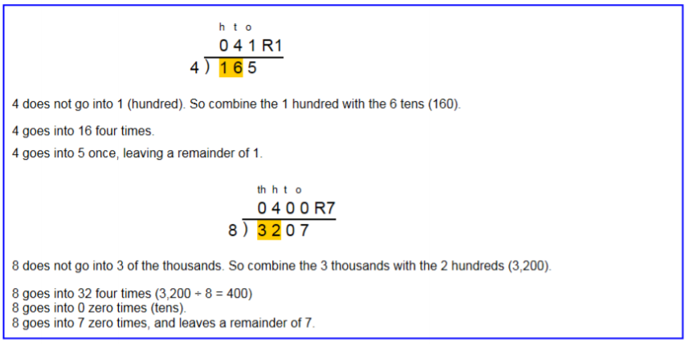Year 6 – Long Division Step 1 – A remainder in the ones

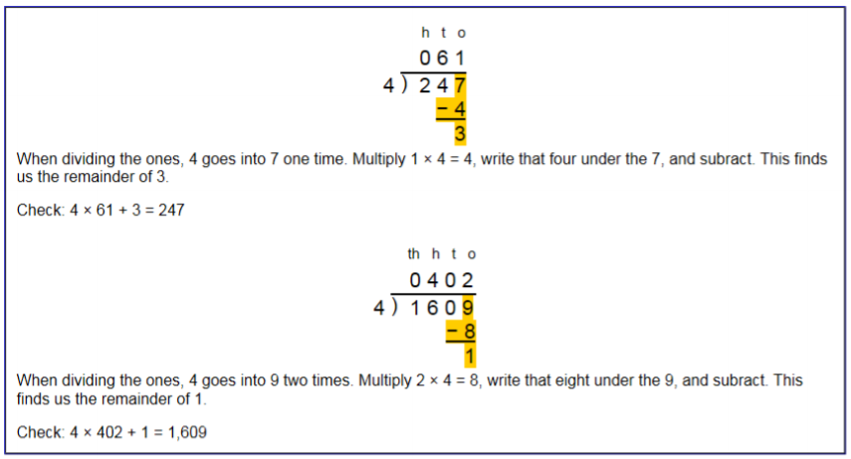

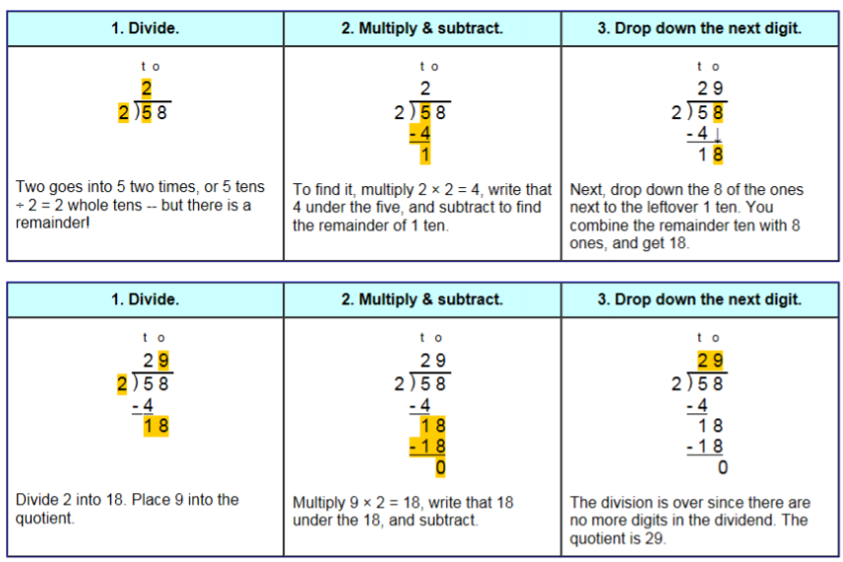Step 2 – A remainder in the tens

Step 2 – A remainder in any of the place values

